**PIZZA SALES SQL PROJECT**

**KPI’s**

1.Total Revenue

select round(sum(total_price),2) as total_revenue from pizza_sales;

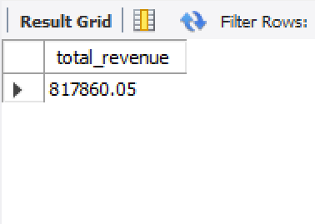

2. Average Order Value

select sum(total_price)/count(distinct order_id) as Avg_Order_Value from pizza_sales;

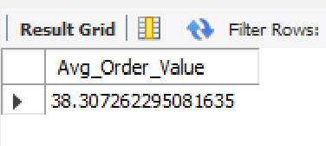

3. Total Pizzas Sold

select sum(quantity) as pizzas_sold from pizza_sales;

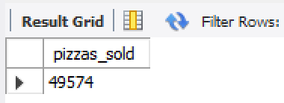

4. Total Orders

select count(distinct order_id) as total_orders from pizza_sales;

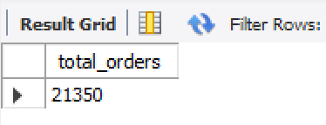

5. Average Pizzas Per Order

select sum(quantity)/count(distinct order_id) as average_pizzas_per_order from pizza_sales;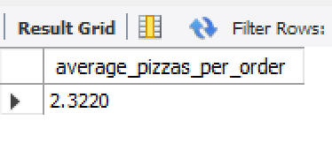

**CHARTS**

1.Daily Trend For Orders

select dayname(Date_of_order) as day,count(distinct order_id) as orders from pizza_sales

group by dayname(Date_of_order);

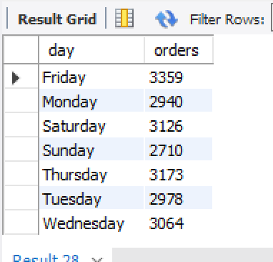

2.Hourly Trend For Orders

select hour(order_time) as order_hour, count(distinct order_id) as orders from pizza_sales

group by hour(order_time);

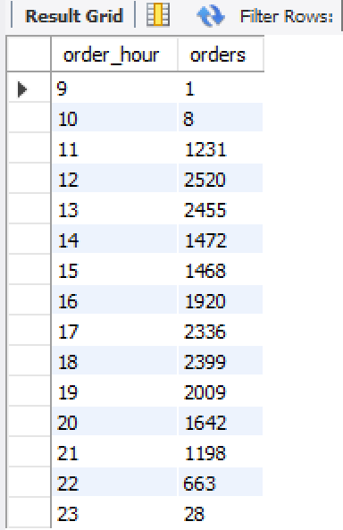

3.Percentage of sales by pizza category

select pizza_category as pizza_category,sum(total_price)*100/(select sum(total_price) from pizza_sales) as percentage_of_Sales

from pizza_sales

group by pizza_category;

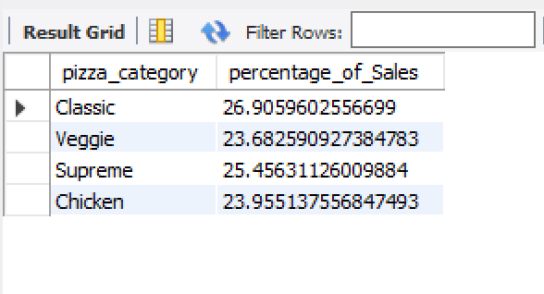

4. Percentage of sales by pizza size

select pizza_size as pizza_size,sum(total_price)*100/(select sum(total_price) from pizza_sales) as percentage_of_Sales

from pizza_sales

group by pizza_size;

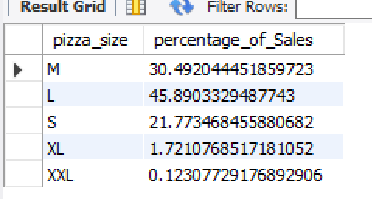

5.Pizzas sold by pizza category

select pizza_category as pizza_category,sum(quantity) as total_pizzas_sold from pizza_sales

group by pizza_category;

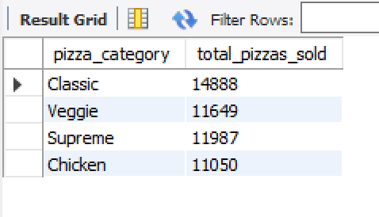

6. Top 5 best selling pizza

select pizza_name as pizza_name, sum(quantity) as total_pizzas_sold from pizza_sales

group by pizza_name

order by sum(quantity) desc

limit 5;

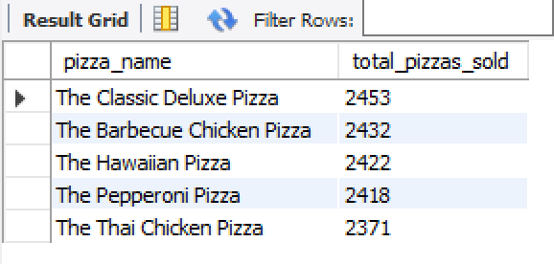

7. Bottom 5 worst selling pizza

select pizza_name as pizza_name, sum(quantity) as total_pizzas_sold from pizza_sales

group by pizza_name

order by sum(quantity) asc

limit 5;

